 | WMRA Associate Membership  Application Form 2023 | 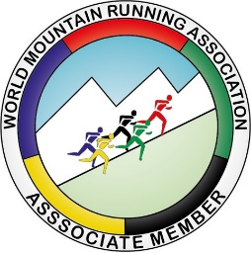

- What does becoming an Associate Member race provide?
- Featured on the WMRA World Ranking Website (Upcoming events).
- Listed on the main events calendar on the WMRA website.
- Link from WMRA calendar page to the Race homepage.
- News items uploaded on the WMRA page before and after the race event (where information is provided to the WMRA by the race organiser).
- 2 to 6 social media articles about your race on the WMRA channels (where information is provided to the WMRA by the race organiser) + post sharing.
- Use of WMRA Associate member logo and Mountain Running World Ranking logo.

- Associate Member Race Fee (12months): 350 Euro
Event Information
NAME of event |  |  |  | (inc. edition)
DATE of event:
VENUE - Place: |  | Country:

ORGANISATION |  |  | (name of club)
WEB SITE:
Contact person: | Name:
 | e-mail: | @
 | Phone:
Results provider: | Company:
 | Contact Name:
 | e-mail: | @
 | Phone:

COURSE DETAILS
Length |  | km
Total ascent |  | m
Total descent |  | m
Start: location, altitude |  | m
Finish: Location, altitude |  | m

Name of WA member fed.

We hereby submit our application to have the mountain race described above to be included in the WMRA calendar as a WMRA Associate member race, valid for one year. We declare that this mountain running race is approved by and held under the auspices of our National Athletic Federation (World Athletics Member) and that the above information is correct.
Date: |  | Event Director: |  | (signature)

NOTE:
- Applications should be sent to WMRA Secretary Nancy Hobbs (nanohobbs@gmail.com )
- Successful applicantants will be asked to pay the associate member fee (350 EUR) after receiving an invoice from the WMRA.

